8 Channels 8 PoE 1HDD Network Video Recorder
E-N-AI08P-1 PRO

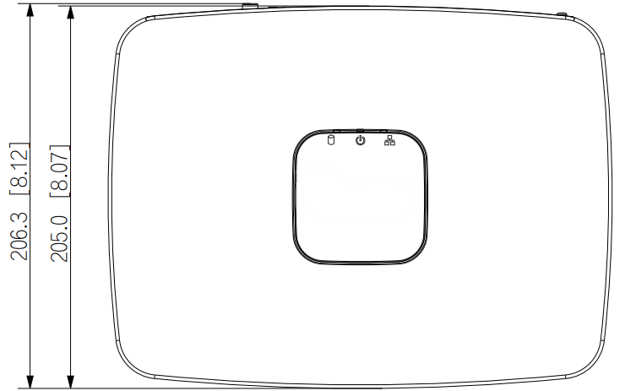
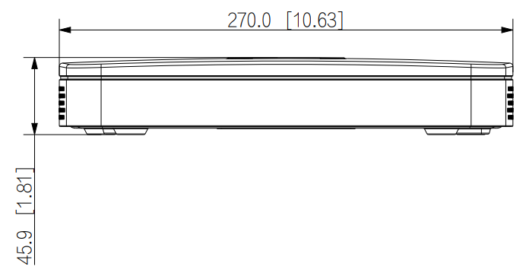
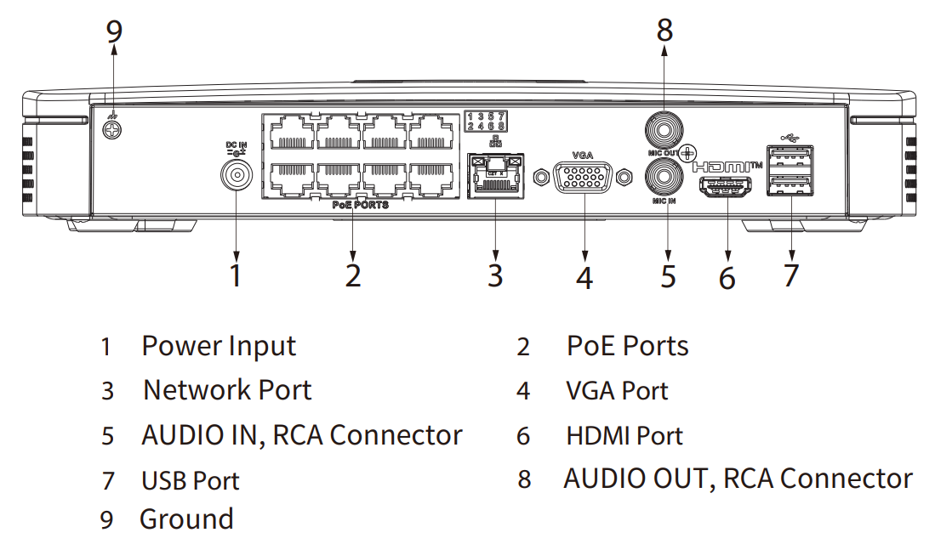
Dimensions mm (inch)
Panels
Technical Specification
System
Main Processor | Industrial-grade processor
Operating System | Embedded Linux
Operating Interface | Web, Local GUI

AI
AI by Recorder | SMD Plus
AI by Camera | Face detection; face recognition; perimeter protection; SMD Plus; people counting; stereo analysis; heat map

Perimeter Protection
Perimeter Performance of AI by Camera (Number of  Channels) | 6 channels

e

Network
Network Protocol | HTTP; HTTPS; TCP/IP; IPv4; IPv6; UDP; NTP; DHCP; DNS; SMTP; UPnP; IP Filter; FTP; DDNS; SNMP; Alarm Server; P2P; Auto Registration; IP Search (Supports IP camera, DVR, NVS, etc.)
Mobile Phone Access | Android; iOS
Interoperability | ONVIF 22.12(Profile T; Profile S; Profile G); CGI; SDK
Browser | Chrome; IE; Safari; Edge; Firefox
Record Playback
Multi-channel Playback | Up to 8 channels
Record Mode | General, motion detection; intelligent; alarm
Backup | USB device and network
Playback Mode | Instant playback, general playback, event playback, tag playback, smart playback
Alarm
General Alarm | Motion detection; privacy masking; video loss; scene changing; PIR alarm; IPC external alarm
Anomaly Alarm | Camera disconnection; storage error; disk full; IP conflict; MAC conflict; login locked; and cybersecurity exception
Intelligent Alarm | Face detection; face recognition; perimeter protection; SMD Plus; people counting; stereo analysis; heat map
Alarm Linkage | Record; snapshot; IPC external alarm output; audio; buzzer; log; preset; email

Port
Audio Input | 1-channel RCA
Audio Output | 1-channel RCA
Disk Interface | 1 SATA port. Each disk can contain up to 20 TB. This limit
USB | 2 (2 rear USB 2.0 ports)
HDMI | 1
VGA | 1
Network Port | 1 (10/100/1000 Mbps Ethernet port, RJ-45)
PoE Port | 8 ports, 10/100 Mbps, IEEE 802.3 af/at

Face Detection
Face Attributes | Gender; age group; glasses; expressions; face mask; beard
Face Detection  Performance of AI by  Camera (Number of  Channels) | 6 channels

Face Recognition
Face Recognition  Performance of AI by  Camera (Number of  Channels) | 6 channels

SMD Plus
SMD Plus by Recorder | 4 channels: Secondary filtering for human and motor vehicle, reducing false alarms caused by leaves, rain and lighting condition change
SMD Plus by Camera | 6 channels

Audio and Video
Access Channel | 8 channels
Network Bandwidth | AI disabled: 160 Mbps incoming, 160 Mbps recording and 80 Mbps outgoing  AI enabled: 80 Mbps incoming, 80 Mbps recording and 60 Mbps outgoing
Resolution | 12 MP; 8 MP; 6 MP; 5 MP; 4 MP; 3 MP; 1080p; 960p; 720p; D1; CIF; QCIF
Decoding Capability | AI disabled: 1-channel 12 MP@30 fps; 2-channel 8 MP@30 fps; 3-channel 5 MP@30 fps; 4-channel 4 MP@30 fps; 8-channel 1080p@30 fps  AI enabled: 1-channel 12 MP@30 fps; 1-channel 8 MP@30 fps; 2-channel 5 MP@30 fps; 3-channel 4 MP@30 fps; 7-channel 1080p@30 fps
Video Output | 1 × VGA, 1 × HDMI  Simultaneous:  HDMI: 3840 × 2160, 1920 × 1080, 1280 × 1024, 1280 × 720  VGA: 1920 × 1080, 1280 × 1024, 1280 × 720  Heterogeneous:  HDMI: 1920 × 1080, 1280 × 1024, 1280 × 720  VGA: 1920 × 1080, 1280 × 1024, 1280 × 720
Multi-screen Display | Main Screen: 1/4/8/9  Sub Screen: 1/4/8/9
Third Party Camera Access | ONVIF; Panasonic; Sony; Axis; Arecont; Pelco; Canon; Hanwha

Compression Standard
Video Compression | Smart H.265+; H.265; Smart H.264+; H.264
Audio Compression | G.711a; G.711u; PCM; G726

Technical Specification
General
Power Supply | 53 VDC, 1.81 A
Power Consumption | Total output of NVR is <10 W(without HDD) Total output power of PoE is 72 W, the maximum output power of a single port is 25.5 W
Net Weight | 0.69 kg
Gross Weight | 1.74 kg
Product Dimensions | 270.6 mm × 206.3 mm × 45.9 mm  (W × L × H)
Packaging Dimensions | 427 mm × 96 mm × 262 mm  (W × L × H)
Operating Temperature | -10 °C to +55 °C
Storage Temperature | -20 °C to +60 °C
Operating Humidity | 10%–93% (RH)
Installation | Desktop or Rack
Certifications | CE-EMC:  EN 55032:2015+A1:2020;  EN IEC 61000-3-2:2019+A1:2021;  EN 61000-3-3:2013+A1:2019+A2:2021;  EN 55035:2017+A11:2020;  EN 50130-4:2011+A1:2014 CE-LVD:  EN 62368-1:2014

Technical Specification

